Fire Coasters
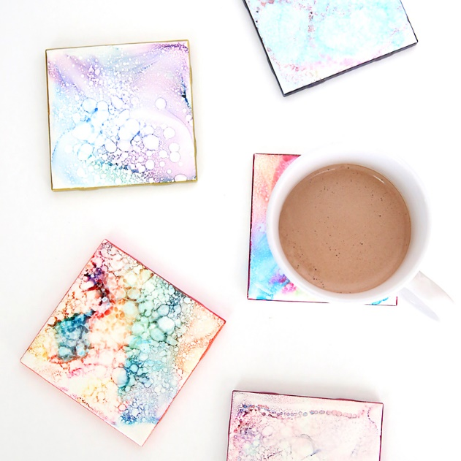
Materials:
- Coaster Size Glossy White Tiles
- Colored Permanent Markers
- 91% Rubbing Alcohol
- Spray Bottle
- Lighter
- Cookie Sheet
- Aluminum Foil

Procedures:
- Give each child a tile.
- Let each child color on the tile. Have them stick to 3 or 4 colors.
- Carefully pour a small amount of alcohol right onto the tile
- Have the child place their tile on a cookie sheet covered with aluminum foil.
- The adult will light each tile on fire carefully.
- Once the flames are gone, check out your cool design!

What’s Going On?
This is really a lesson in the concepts of solubility, color mixing, and the movement of molecules. The markers contain permanent ink, which will not wash away with water. Permanent ink is hydrophobic, meaning it is not soluble in water. However, the molecules of ink are soluble in another solvent called rubbing alcohol. This solvent carries the different colors of ink with it as it spreads.

